

Practical Report

For IoT Practical



January 1, 2022

Darshan Ramjiyani (DSP)

DOCS, KSKV Kachchh University

* **4.2 Serial Communication – Send Various type of data**

Using Arduino Serial communication, we can pass or send various type of data like binary, octal, decimal and hexadecimal.

* Code:

int number = 1;

void setup()

{

  int baudRate = 9600;

  /* Established Serial Communication. */

  Serial.begin(baudRate);

  /* Wait until Serial Communication not established. */

  while(!Serial){}

  /* Send data through Serial Communication. */ param.

  Serial.println("- Name of Author : DSP -");

  Serial.println("---------------------------------------------------------");

}

void loop()

{

 Serial.println("----------Process Start!----------");

 Serial.print("Interger number ");

 Serial.print(number);

 Serial.print(" & Binary : ");

 Serial.print(number, BIN); /* For Binary Data*/

 Serial.

(number, HEX);

 Serial.flush();print(" & Octal : ");

 Serial.print(number, OCT); /* For Octal Data*/

 Serial.print(" & HEXADECIMAL : "); /* For Hexadecimal Data*/

 Serial.println

 Serial.println("----------Process Done!----------");

 delay(2000);

 number++;

}

* Output:

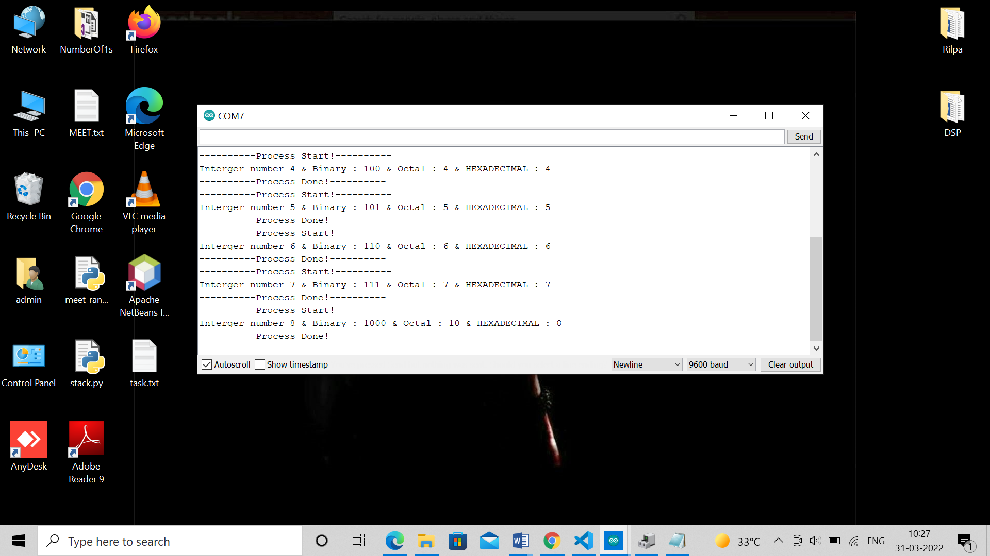

Output From Dwaidh Terminal